CITY OF HOLLYWOOD
INTEROFFICE MEMORANDUM

TO: Mayor and Commissioners DATE: 11/25/24

FROM: Douglas R. Gonzales, City Attorney

SUBJECT: Proposed Acceptance of A State Of Florida Division Of Historical Resources Grant In The Amount Of $50,000.00 To Create A Hollywood Historic Properties Survey; Authorizing The Expenditure Of Matching Funds In The Amount Of $50,000.00; Authorizing The Appropriate City Officials To Execute All Applicable Grant Documents And Agreements. (24-G-85)
________________________________________________________________

I have reviewed the above referenced Agreement with the participating Department/Office(s), and the proposed general business terms and other significant provisions are as follows:

1) Department/Division involved – Department of Development Services

2) Type of Agreement – State of Florida Grant Agreement

3) Method of Procurement (RFP, bid, etc.) – n/a

4) Term of Contract:
a) initial – funds must be expended by 6/30/25
b) renewals (if any) – n/a
c) who exercises option to renew – n/a

5) Contract Amount – $50,000.00

6) Termination Rights –
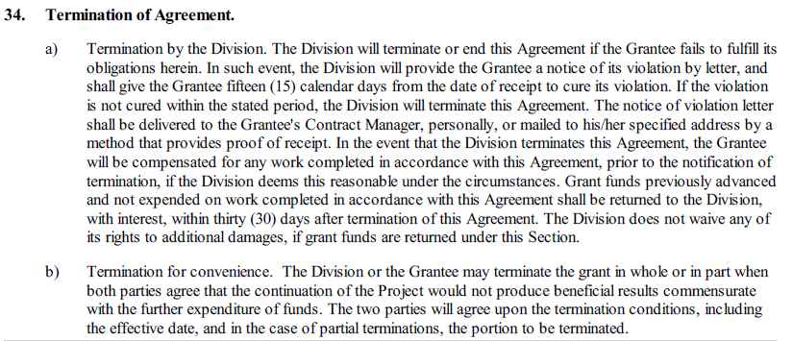

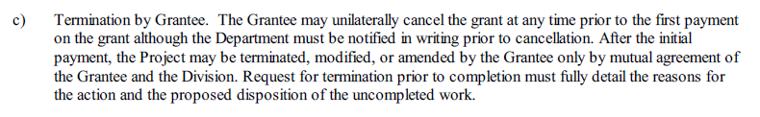
7) Indemnity/Insurance Requirements –

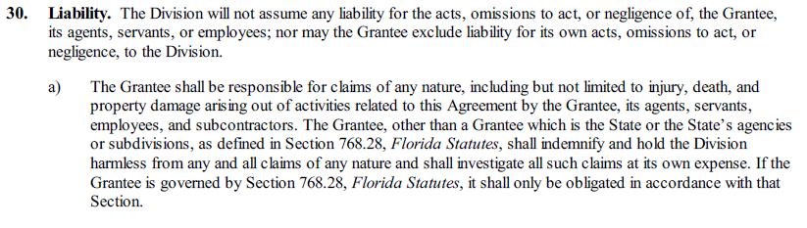

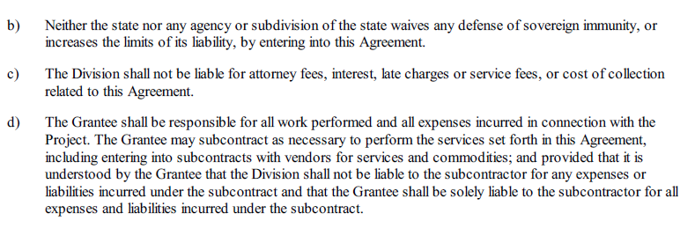
8) Scope of Services – City will use grant funds to hire a historic preservation consultant to conduct a historic resources survey in Hollywood, Florida, including a survey report conforming to Chapter 1A-46, Florida Administrative Code (FAC), and a minimum of four hundred (400) new/updated Florida Master Site File (FMSF) forms.

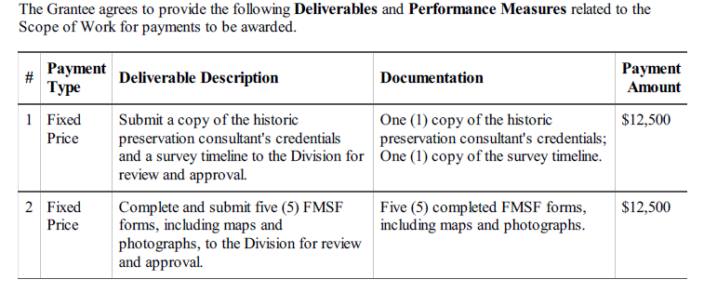

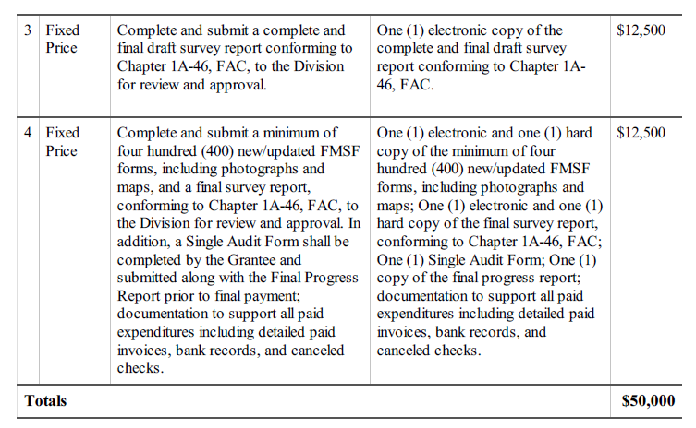

9) Other Significant Provisions:

Section 13: The Grantee is required to provide a 100% match of the Grant Award Amount. Of the required match, a minimum of 25% must be cash on hand. The remaining match may include in-kind services, volunteer labor, donated materials, and additional cash. For projects located in Rural Economic Development Initiative (REDI) counties or communities that have been designated in accordance with Sections 288.0656 and 288.06561, Florida Statutes, Grantees may request a waiver of the match amount. Grantees that are Certified Local Government (CLG) organizations and Main Street Program organizations are not required to provide a match. The Grantee must submit documentation that the minimum match requirements have been met and provide to the Division documentation evidencing expenses incurred to comply with this requirement.

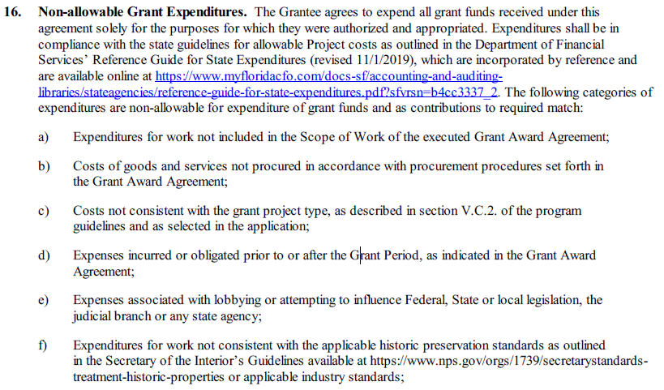
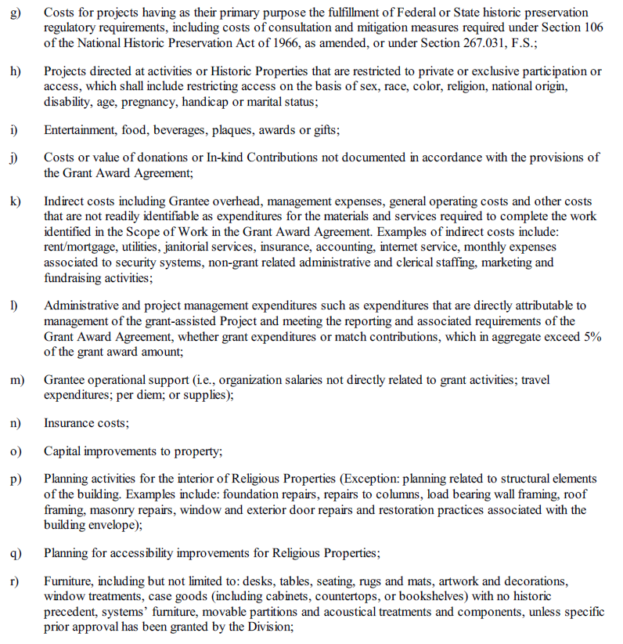
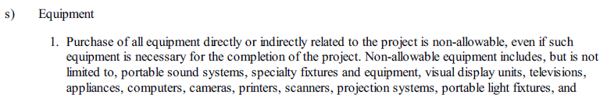

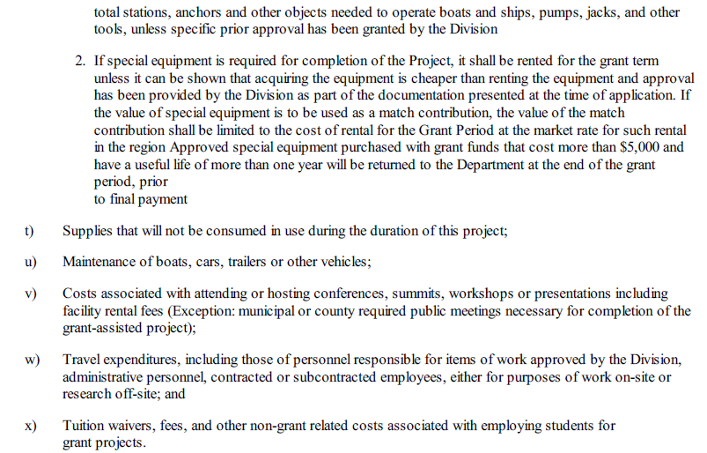

cc: George R. Keller, Jr. CPPT, City Manager

